Copilot Studio: Build Agents With SharePoint List Knowledge

Introduction: The Car Inventory Lookup Agent
The Car Inventory agent is used by a car dealership to lookup vehicles in their car inventory SharePoint list.
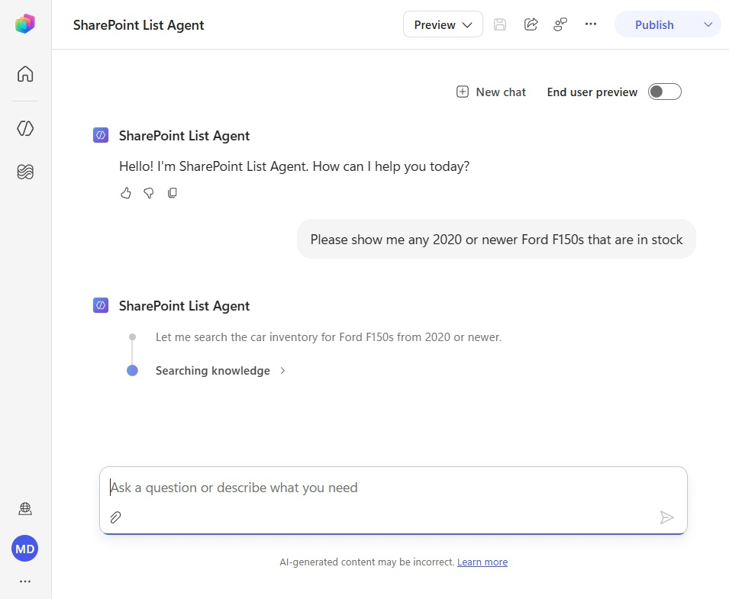
It can return a table of results to the chat or respond to customers who send an email to the agent’s inbox.
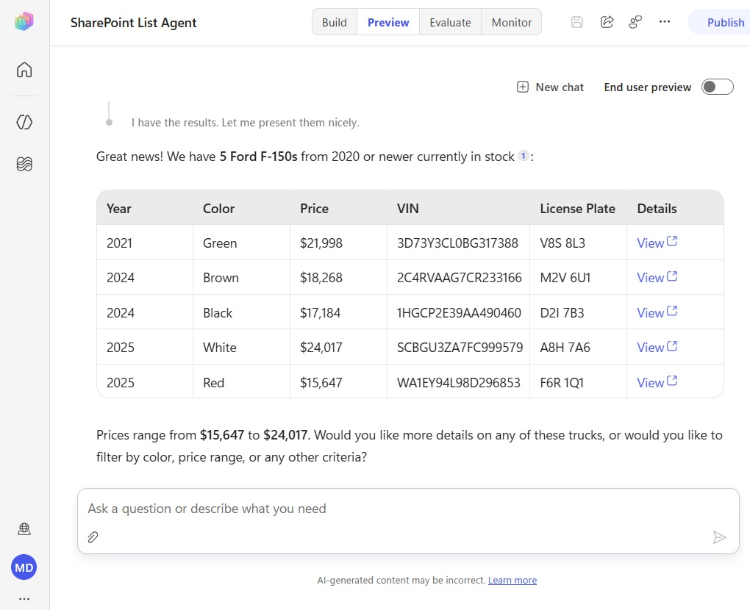
Setup The SharePoint List
Open SharePoint and create a new SharePoint list with the following columns:
Column Name | Column Type
Title | Text
Year | Number
Make | Text
Model | Text
Price | Number
Sold | Number (0 or 1)
VIN | Text
LicensePlate | Text
Color | Text
InventoryDate | Date Only
Download the Car Inventory Excel spreadsheet data from Github and use it to populate the SharePoint List.
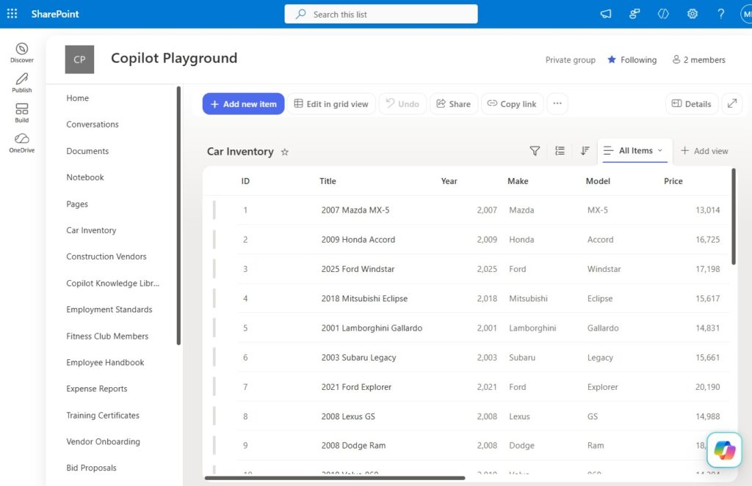
Create A New Agent In Copilot Studio
Open Copilot Studio and create a new agent and add a set of basic instructions.
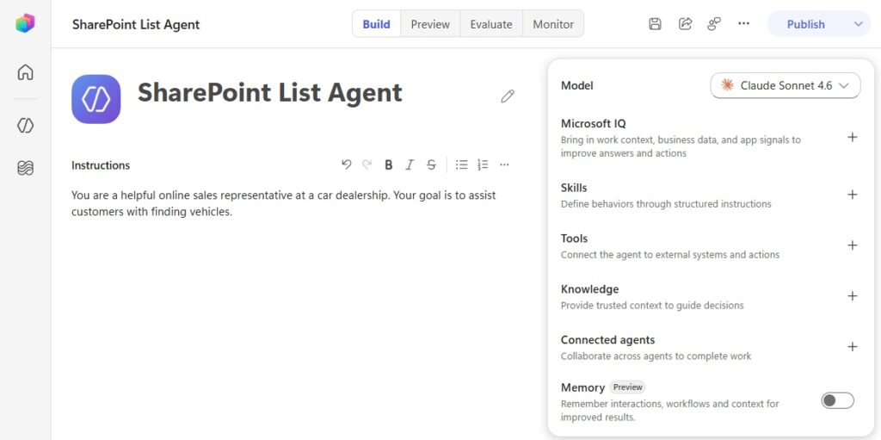
Copy and paste the following text into the agent’s instructions:
You are a helpful online sales representative at a car dealership. Your goal is to assist customers with finding vehicles.​​
Add The SharePoint List As Agent Knowledge In Copilot Studio
In Copilot Studio, select add knowledge from the right-side menu. Then select SharePoint from the list of knowledge sources that appears.
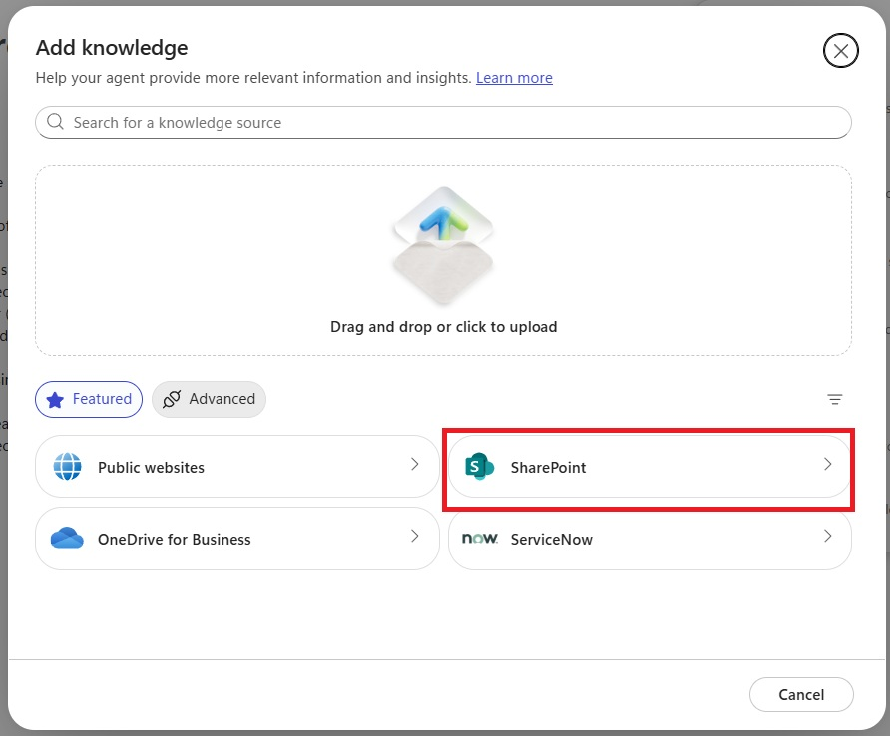
Copy and paste the URL of the SharePoint list into the next menu and press the add button. Then press the add to agent button at the bottom of the menu.
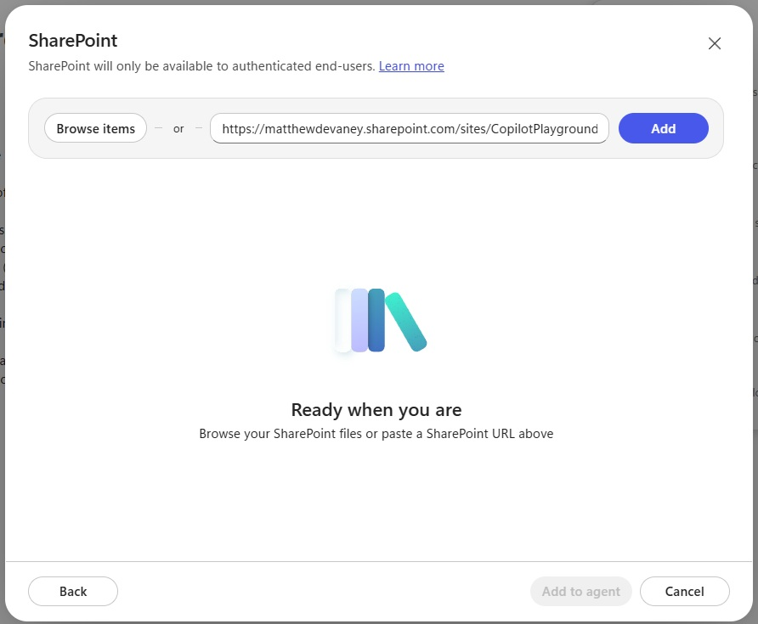
The Car Inventory SharePoint list now appears in the knowledge section for the agent.
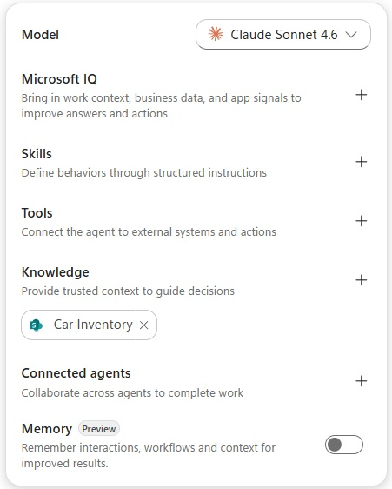
Test The SharePoint List Knowledge In The Copilot Studio Preview Tab
Now that we’ve added the SharePoint list, the next step is to perform a test. Publish the agent, then navigate to the Preview menu. Ask the agent the question “please show me any 2020 or newer Ford F150s that are in stock.”
The agent returns the complete list of matching results from the SharePoint list along with a link to the list item.
Define The SharePoint List Results For Multiple Items
It is a best practice to define what columns should be included by default when the agent returns a result from SharePoint along with sorting and filtering criteria.
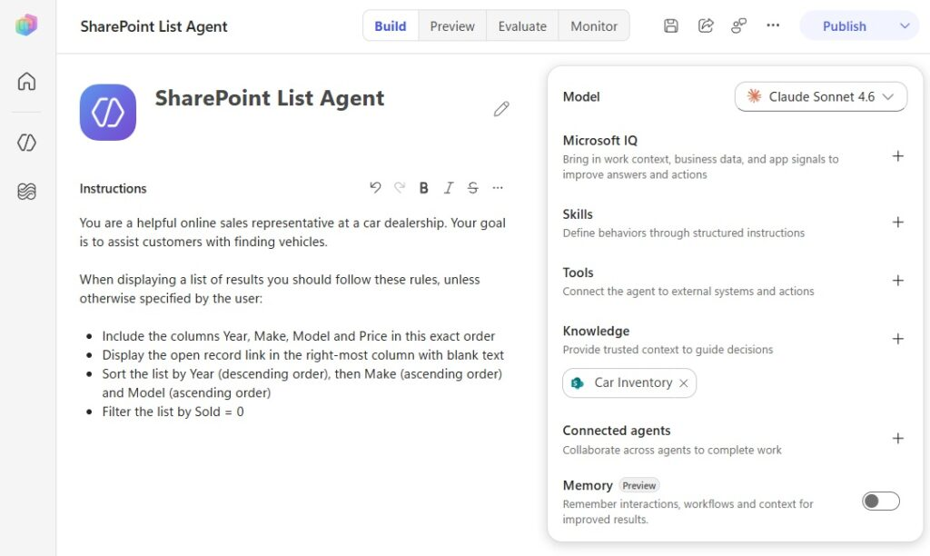
Add the following text to the agent’s instructions:
When displaying a list of results you should follow these rules, unless otherwise specified by the user:
* Include the columns Year, Make, Model and Price in this exact order
* Display the open record link in the right-most column with blank text
* Sort the list by Year (descending order), then Make (ascending order) and Model (ascending order)
* Filter the list by Sold = 0‌​‌
Then ask the same question once again: “please show me any 2020 or newer Ford F150s that are in stock.”
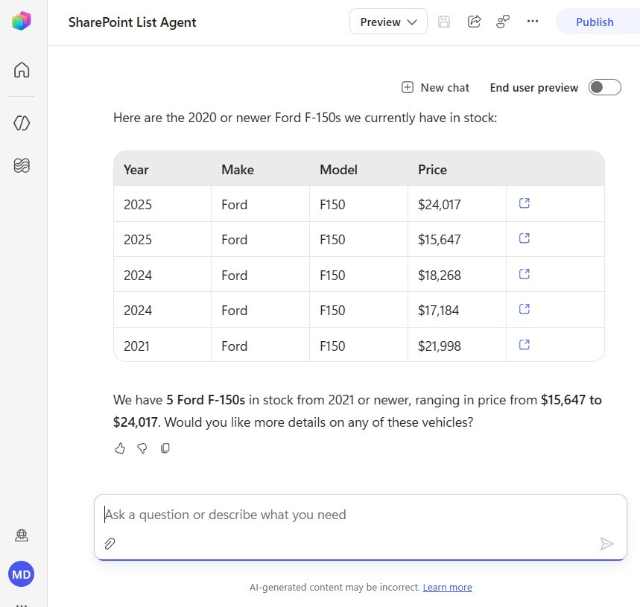
Describe How The Agent Will Display A Single Result
The agent should also have instructions for how to display a single list item.
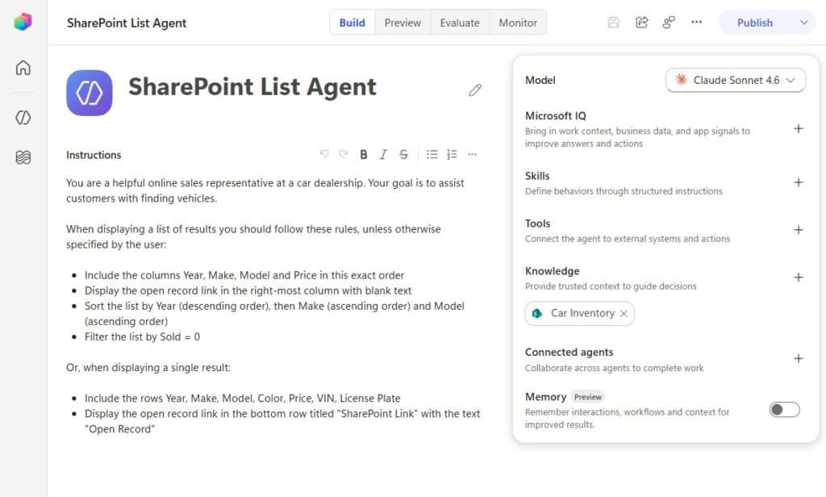
Add the following text to the agent’s instructions:
Or, when displaying a single result:​‌
​‌​‌​‌​‌​‌* Include the rows Year, Make, Model, Color, Price, VIN, License Plate​‌
* Display the open record link in the bottom row titled “SharePoint Link” with the text “Open Record”​​‌
Start by asking the question “please show me any 2020 or newer Ford F150s that are in stock.”
Then say “tell me about the 2021 Ford F150.” The agent returns only the details outlined its instructions for the single list item result.
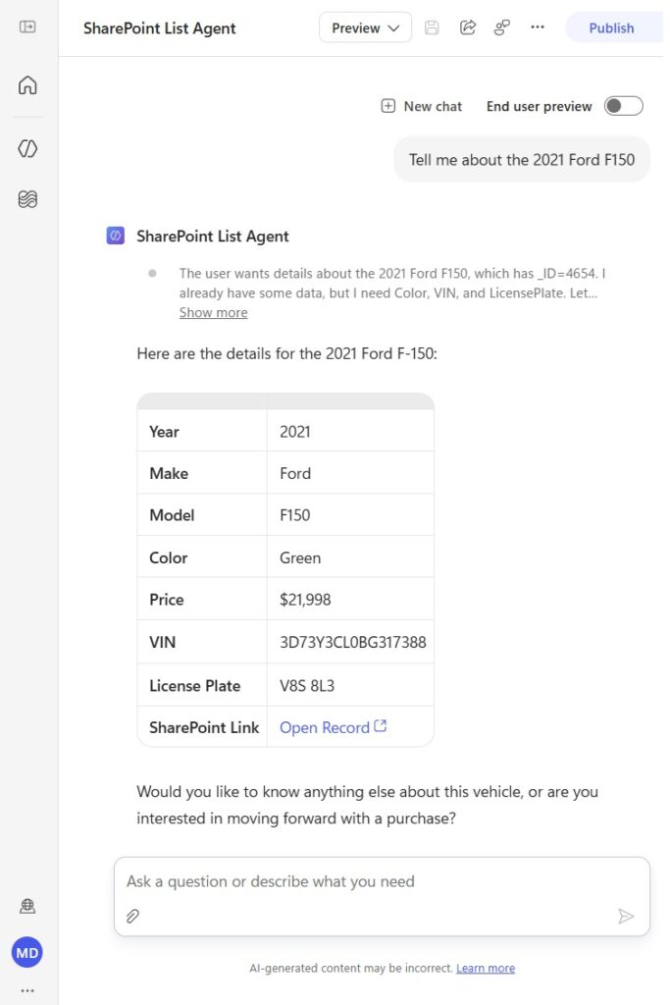
Generate An Excel Spreadsheet From A SharePoint List In Copilot Studio
Copilot Studio has a built-in capability to generate Excel spreadsheets from a SharePoint list. Start a new chat and ask the question “What do we have in stock for BMW, Benz and Volkswagen that’s newer than 2020?”
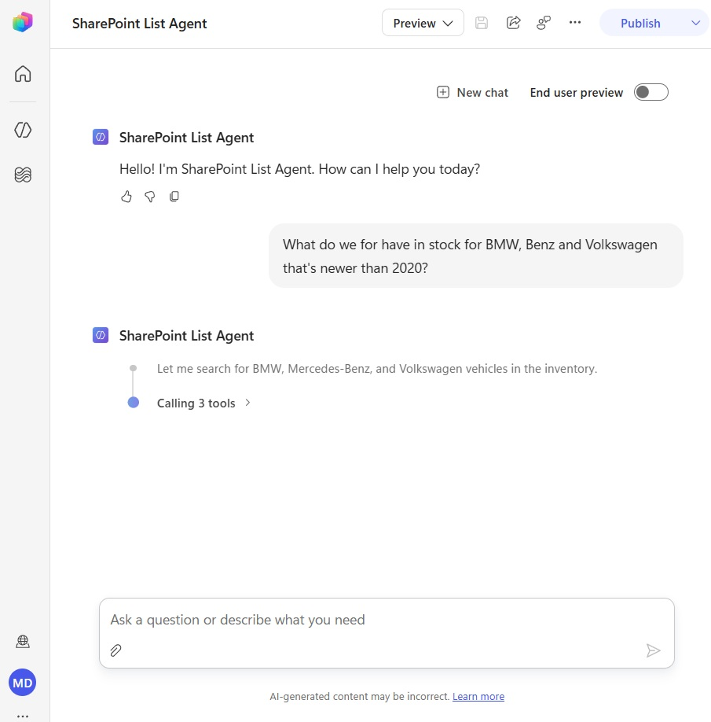
The agent returns the result shown below. Now say to the agent “Excellent. Can you please give me this as an Excel spreadsheet with each model being on a different tab?”
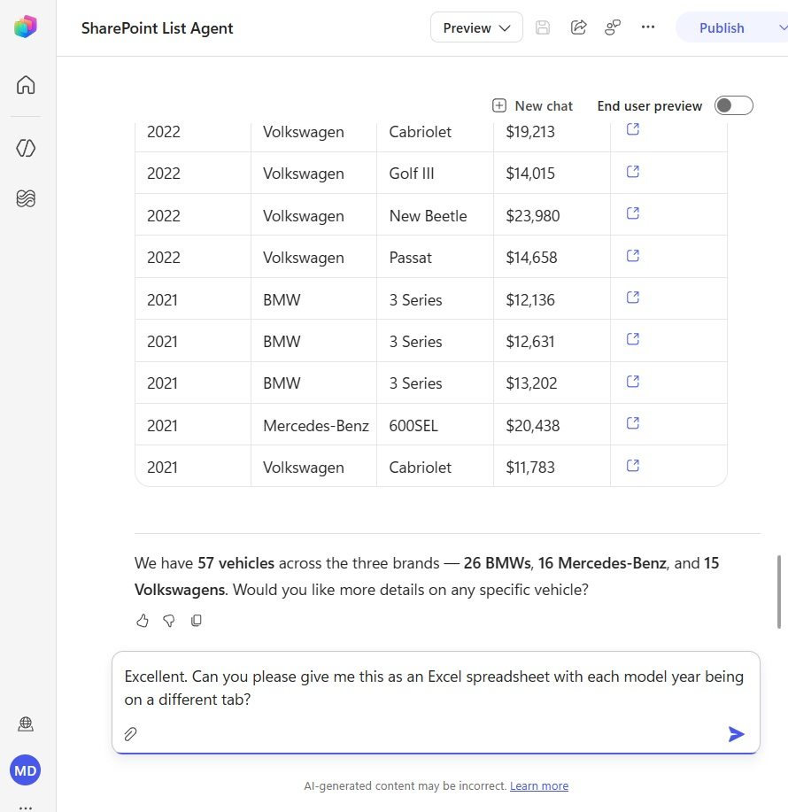
The agent responds by generating an Excel spreadsheet. Select the Excel spreadsheet to open it in Excel.
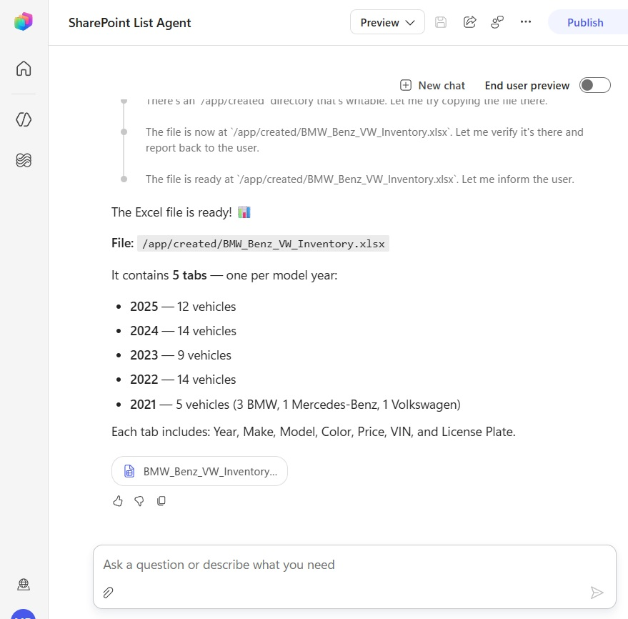
The file includes all 57 vehicles, grouped by model-year on separate tabs just as requested.
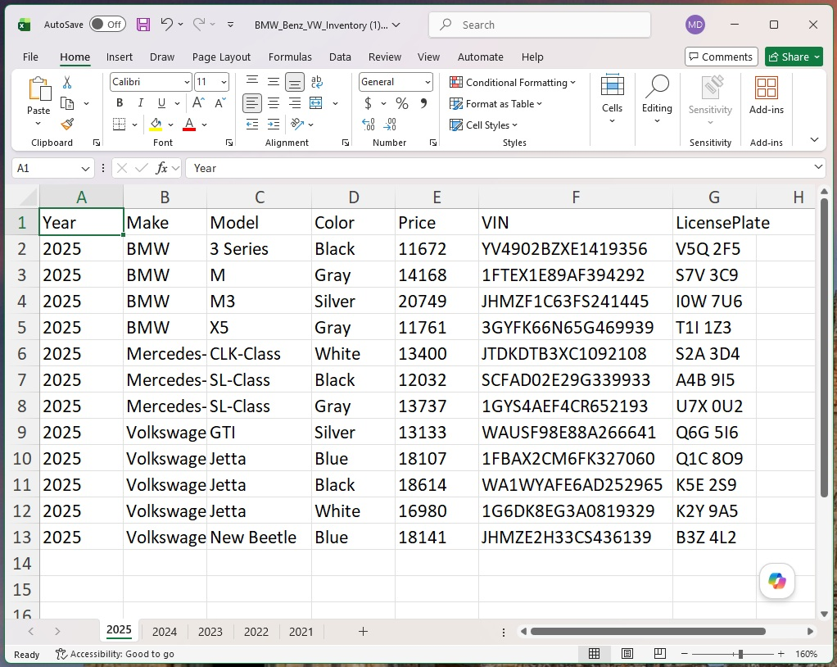
Respond To An Email Using A SharePoint List
The agent can also use SharePoint list data to respond over email. To do this, go to the workflows menu and select the new workflow button.
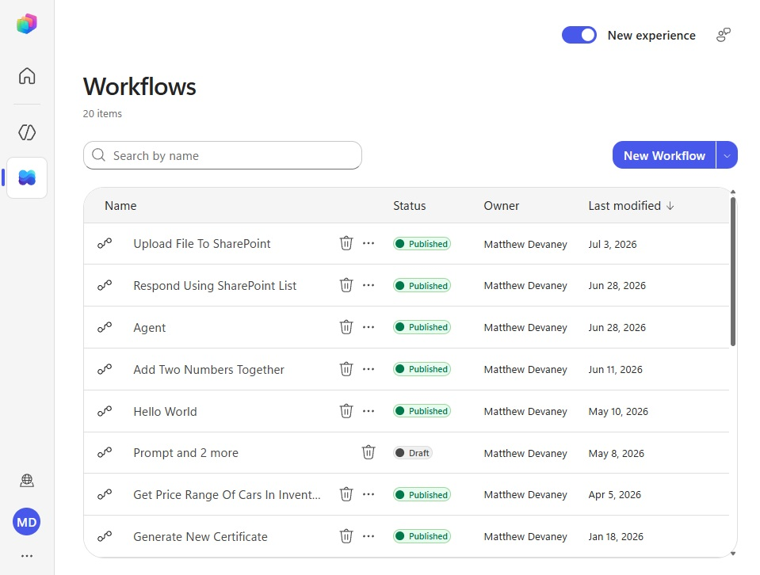
Use the Office 365 Outlook – When A New Email Arrives trigger and select the Inbox folder for the subject filter.
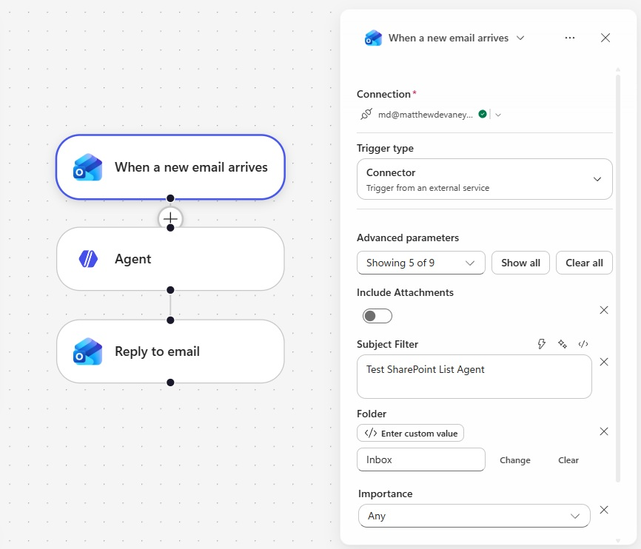
Then add an Agent action and select the SharePoint List Agent.
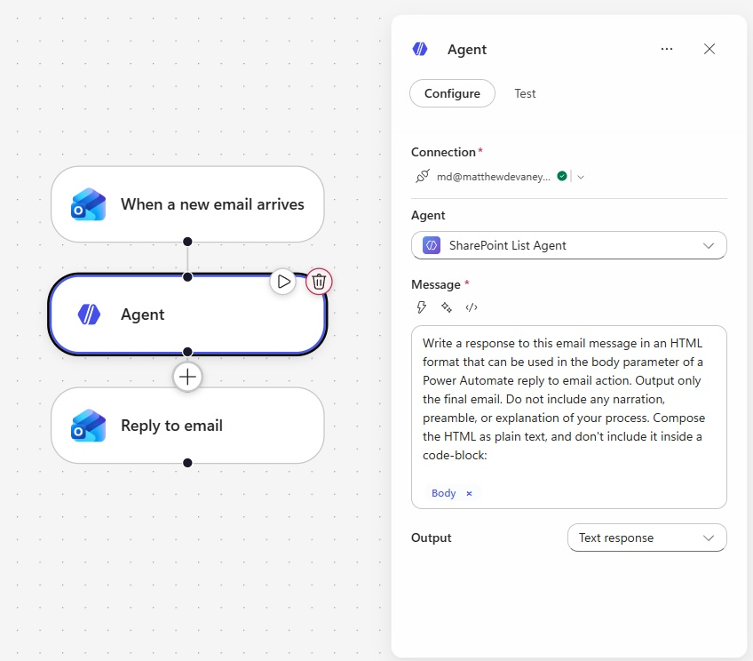
Use the following text as instructions with and include the Body parameter from the trigger.
Write a response to this email message in an HTML format that can be used in the body parameter of a Power Automate reply to email action. Output only the final email. Do not include any narration, preamble, or explanation of your process. Compose the HTML as plain text, and don’t include it inside a code-block:
[When A New Email Arrives.Body]
Finally, insert an Office 365 Outlook – Reply To Email action. Include the message id from the trigger, the agent result for the body and select yes for the reply all parameter. Save and publish the workflow.
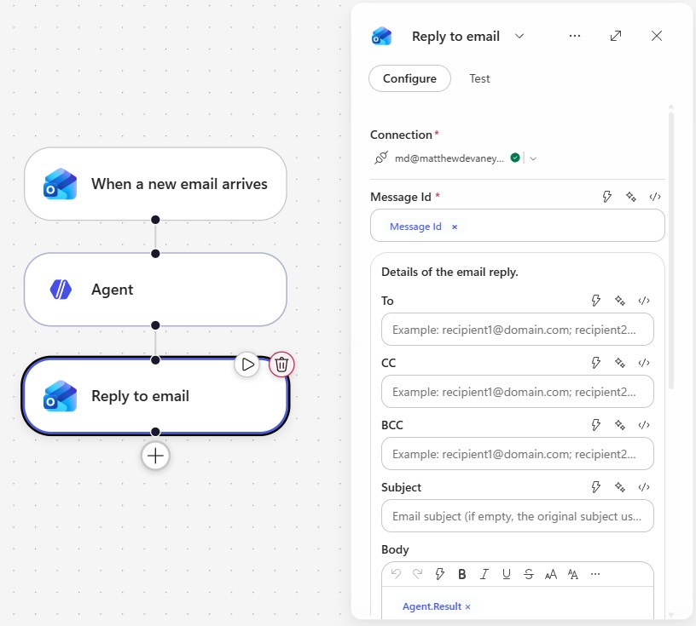
Send An Email To Test The SharePoint List Agent In Copilot Studio
We’re done. To test the agent, send an email to the agent’s inbox in Outlook.
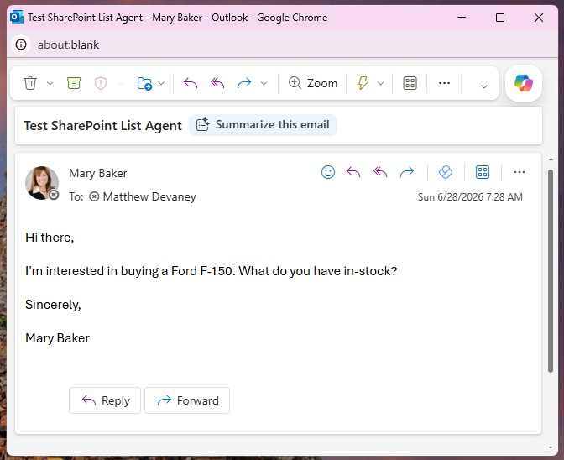
The agent will respond with a message that includes SharePoint list results.


